Practical - 9
Practical Title : Secure User Registration with Database Insert, Duplicate Email Check, and Password Hashing
Problem Definition: Implement secure user registration by inserting user details into MySQL using MYSQLi. Validate input on frontend and backend, check duplicate email/username, hash passwords using password_hash(), and display appropriate messages.
Theory

Is password_hash() used before storing passwords?
Answer: Yes, password_hash() is used before storing the password, so the password is stored securely as a hash

Is duplicate email/username checked?
Answer: No, duplicate email/username checking is not currently implemented in the code.

Are frontend and backend validations consistent?
Answer: Partially, frontend and backend validation should both validate the same required fields and password confirmation.

Implementation :
- Created a registration form to collect user details.
- Connected PHP with the MySQL database using MySQLi.
- Added password confirmation validation.
- Used password_hash() to securely hash the password before storing it.
- Inserted the user details into the users table.
- Displayed a success message after successful registration.
- Redirected the user back to the registration page after submission.

Evidence of Work (Screenshots)
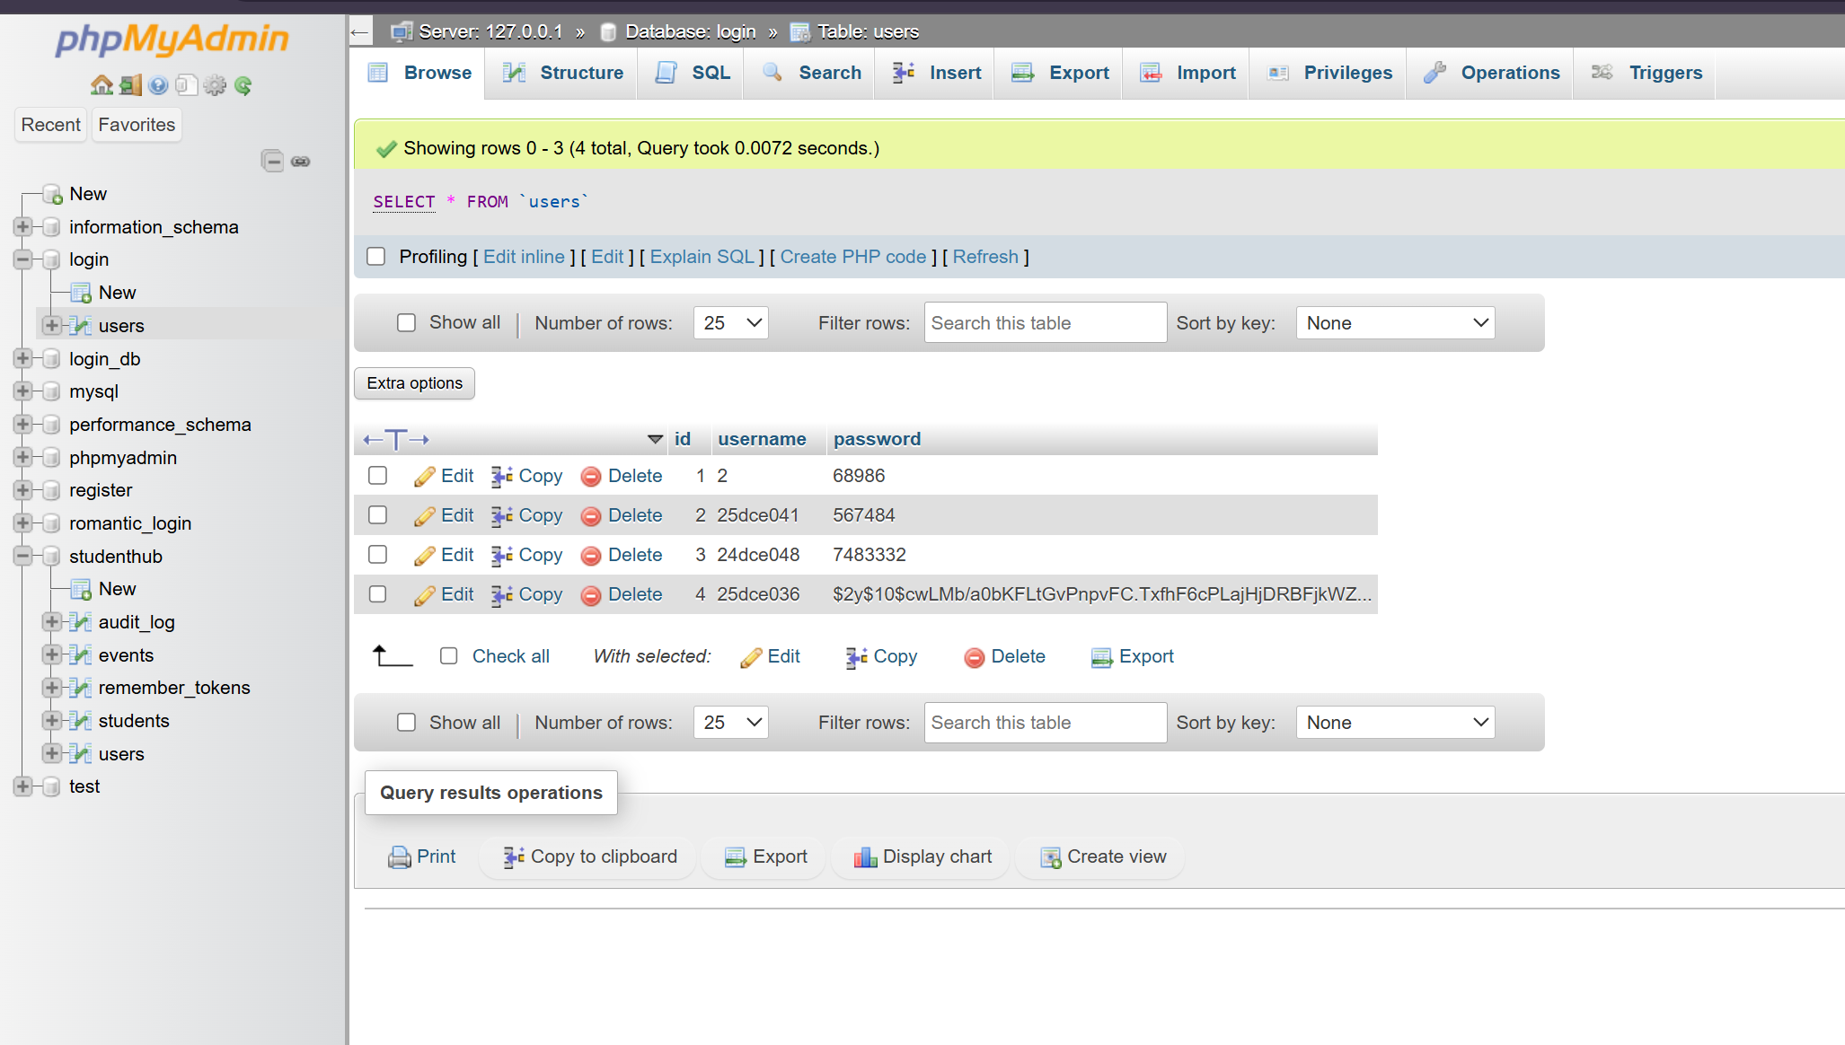

GitHub Repository Link:
https://github.com/kansagarahasti24/WDF

Challenges Faced:
- Connecting the PHP form with the MySQL database.
- Implementing secure password hashing using password_hash().
- Validating password and confirm password fields.
- Handling database insertion errors and displaying appropriate messages.

Learning Outcomes:
- Learned how to connect PHP with a MySQL database using MySQLi.
- Learned how to validate user input in PHP.
- Learned how to securely hash passwords using password_hash().
- Learned how to insert registration data into a MySQL table.
- Learned how to handle database errors and display appropriate messages..

Faculty Remarks: (Keep this blank for faculty)

